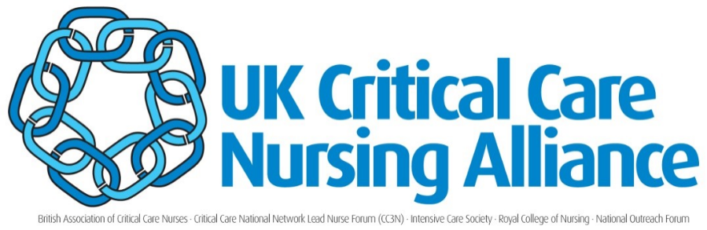
UK Critical Care Nursing Alliance (UKCCNA)
Terms of Reference and Working Methods

Purpose
The UK Critical Care Nursing Alliance (UKCCNA) provides a structured mechanism to facilitate collaborative working for nationally recognised professional critical care nursing groups across the United Kingdom.
The aims of the UKCCNA are:
- To develop a shared understanding of issues impacting on critical care nursing linked to the future delivery of critical care at a national and local level incorporating:
- Training & Education
- Workforce
- Standard setting
- Research
- To provide a shared vision and accompanying strategies to assist in the development of a nursing workforce who are equipped to provide a high-quality service.
- To actively inform and contribute to the broader multi-professional quality agenda for critical care services across the UK.
- To identify, discuss and address issues of common concern and avoid unnecessary duplication of effort and gain a clear consensus.
- To be proactive and visionary about future service requirements and quality assurance to enhance the service, quality of care, patient experience and outcomes.
- To determine the need and scope for future research aligned to nursing issues in critical care.

Membership
Membership of the Alliance will be made up of nurses from the following critical care groups:
- British Association of Critical Care Nurses (BACCN)
- Critical Care National Network Nurse Lead Forum (CC3N)
- Intensive Care Society (ICS) Nursing Professional Advisory Group (NPAG)
- National Outreach Forum (NoRF)
- Royal College of Nursing (RCN) Critical Care & Flight Nursing Forum
- Paediatric Critical Care Society (PCCS)
Critical Care Military Nursing will be represented via the BACCN & RCN.

Each member group will have two seats on the UKCCNA: usually the chair and deputy chair. Other members can be co-opted as required.

Quorum Requirement
There must be representation from at least three member groups for the meeting to be deemed quorate. The chair and/or deputy chair must be present.

Chairmanship
- The Chair and deputy Chair will normally hold the role for a term of 2 years. This term may be extended if required with agreement from the alliance membership.
- Both roles will ideally rotate through the six groups that constitute the UKCCNA.
- The chair and deputy chair should be from different member groups where possible and should be appointed from the current representatives within the UKCCNA.
- For the purpose of succession planning, the deputy chair should normally aim to take over from the chair after their period of chairmanships comes to an end.
- The Chair and deputy chair should not be replaced together under normal circumstances.
- The outgoing chair should remain as a member of the alliance for a period of 12 months after standing down to provide stability. This person will be in addition to the representation from their group.
- Self or peer nominations may be submitted to the UKCCNA as the current tenure is nearing completion. Election of roles will be via a forum vote.

The chair will prepare and circulate agendas and papers prior to meeting dates. The deputy chair will take minutes of meetings, update the action log and assist the chair with administration and organisation of meetings as required.

Communication strategy
A website hosted under the Faculty of Intensive Care Medicine (FICM) site will provide outfacing information about the UKCCNA and its representatives. A Twitter account specific to the UKCCNA will be used to promote the group and its work and to request information from the wider public as required. Group representatives will support the communication strategy by undertaking activities such as writing blogs, and other initiatives relevant to their role.

Outside of scheduled meetings, email will be the primary medium for communication. Each group member must provide at least one email address (home or work), which will be used for this purpose. Group members will also be invited to join a whattsapp group to optimise communication. However, all information shared in this way will also be made available via email.

Minutes taken at each UKCCNA meeting and an action log will be circulated to members via email at least one week prior to any meeting, with an expectation that group members will respond to action requests in a timely manner. External requests for UKCCNA minutes will be accepted (unless there are exceptional circumstances supporting a refusal) and managed by the Chair or Deputy Chair.

Reporting Mechanisms
Group members have a responsibility to act as a conduit of information between their own organisation and the UKCCNA and to actively seek the opinions of those organisations they represent to influence discussions and actions taken by the Alliance. Each member should email the Chair a brief update on organisational activity at least one week prior to a scheduled meeting. In the event of a vote, each organisation will have one vote.

The chair (or deputy) of the UKCCNA will attend and provide an update of UKCCNA activity and raise key nursing issues at the multi-professional UK Critical Care Leadership forum hosted by the Faculty of Intensive Care Medicine, the National Emergency Critical Care (NECC) group hosted by the Intensive Care Society, the Adult Critical Care Clinical Reference Group (CRG) and other NHSEI convened forums of relevance. Key issues from these meetings will be reported back to Alliance members at each UKCCNA meeting and minutes circulated via email.

Frequency of Meetings:
Quarterly meetings will be held, two of which will follow the critical care leadership forum. Meetings may be attended in person or using telephone/video conferencing facilities. Additional meetings and working groups may be called if required.

Endorsements
When endorsement from the UKCCNA is requested, representatives of each member group will take responsibility for handling the process within their own organisation. In the event that some organisations do not agree to endorsement, this will be made clear in the endorsement statement.

Review of the Terms of Reference.
The TOR will be reviewed biannually. Date of next review: March 2022

