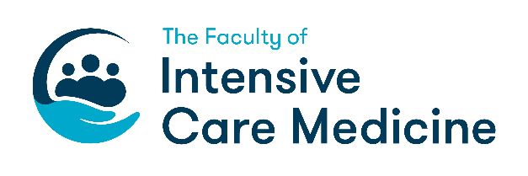
Monday 28 February 2022

Training Leadership Annual Meeting
Microsoft Teams (Links will be sent to all delegates and speakers)
5 CPD points expected

09.00 – 09.15 | Welcome, virtual Tea & Coffee, Introductions and Ground rules | Dr Andrew Sharman
09.15 – 10.00 | The new Curriculum – How is it going? | Dr Matt Williams  Dr Andrew Sharman  Ms Natalie Bell
10.00 – 10.30 | ICM Workforce now and in 10 years | Dr Jack Parry-Jones
10.30 – 11.00 | Recruitment – Then, Now and the Future | Dr Tim Meekings
11.00 – 11.30 | Break
11.30 – 12.00 | How to attract and retain ICU Consultants to Smaller Units | Dr Chris Thorpe
12.00 – 12.30 | How to inspire Medical Students to ICM | Dr Vidhi Taylor-Jones
12.30 – 13.00 | Regional Advisor Meeting  Dr Matt Williams (ICM Lead RA)  Training Programme Directors Meeting  Dr Liza Keating (ICM TPD)  Faculty Tutors Meeting  Dr Andrew Sharman (Deputy Lead RA) | RAs  TPDs  FTs
13.00 – 13.45 | Lunch
13.45 – 14.15 | FFICM then and during COVID | Dr Vickie Robson
14.15 – 15.00 | Sim and it’s role in ICM training | Dr Andrew Jacques
15.00 – 15.30 | I am a terrible Trainee – Why? | Dr Michael Bannon
15:30 – 16:00 | Afternoon tea and Discussion of day | Dr Andrew Sharman

